MusicDB
A project to store and manage music metadata.

Project Requirements

- Add a New Track: As a user, you should be able to add a new track to an artist's catalogue, capturing attributes such as track title, genre, length, etc.
- Edit Artist Name: As a user, you should be able to edit an artist's name to accommodate instances where artists have multiple aliases.
- Fetch Artist Tracks: As a user, you should be able to fetch all tracks associated with a specific artist.
- Artist of the Day: As a user, you should be able to see a different "Artist of the Day" in a cyclical manner on the homepage each day, ensuring a fair rotation through the entire catalogue of artists. This means if there are n artists, after n days, the cycle restarts with the first artist, ensuring an equal chance for each artist to be the "Artist of the Day".

Possible Solution

Phase 1: Backend
We are going to create following APIs
- Get /track // To get list of all tracks or filter using query
- Get /track/{id} //To get track by id
- Post /track // To create a new track
- Patch /track/{id} // To edit track metadata

- Get /artist // To get a list of artist or filter using query
- Get /artist/{id} // To get a list of artist by id
- Post /artist // To create an artist
- Patch /artist // To update an artist
- Get /artist/aotd // To get a artist of the day
- Get /artist/{id}/tracks // To get all tracks of a artist by id

- Patch /alias/{artist_id}add/{name} to add a alias
- Patch /alias/remove/{id} to remove a alias by id

- Patch /collab/{track_id}/add/{artist_id} // To add a musicians to a track
- Patch /collab/{track_id}/add/{artist_id} // To remove a musicians from a track

Phase 2: Frontend
We are going to create following pages

- Home Page: Artist of the day and links to following pages :
- Track Table View: A search bar, A list of tracks
- Track Add/Edit View: A page to edit/add a track
- Artists Table A search bar, View: A list of artists
- Artist Add/Edit View: A page to edit/add artist

Software Stack & Requirements for development

Backend
Language: Java 17
Framework: Spring Boot 3.1.3
Database: MySQL

Frontend
Language: TypeScript
Framework: Angular: 16.2.5
Node: 18.17.1
Package Manager: npm 9.6.7

Other Tools
Version Management: Git
Container: Docker

Other Considerations:
1. I assume that we are going to have only few artists in our system (< 300) because with given logic it will take 300 days before last artist's turn.

Possible Future Improvements
1. Albums – Options to have albums as entity and group tracks in album.
2. Band – Options to have band as entity and group artists in bands.

Guide for local system development.

Backend

- Open backend folder in your preferred IDE, this guide follow intellij, but other IDE should work similarly.
- Open backend/src/main/java/com/iceservices/musicdb/App.java
- You should be able to run the file in your IDE using a configuration like this :
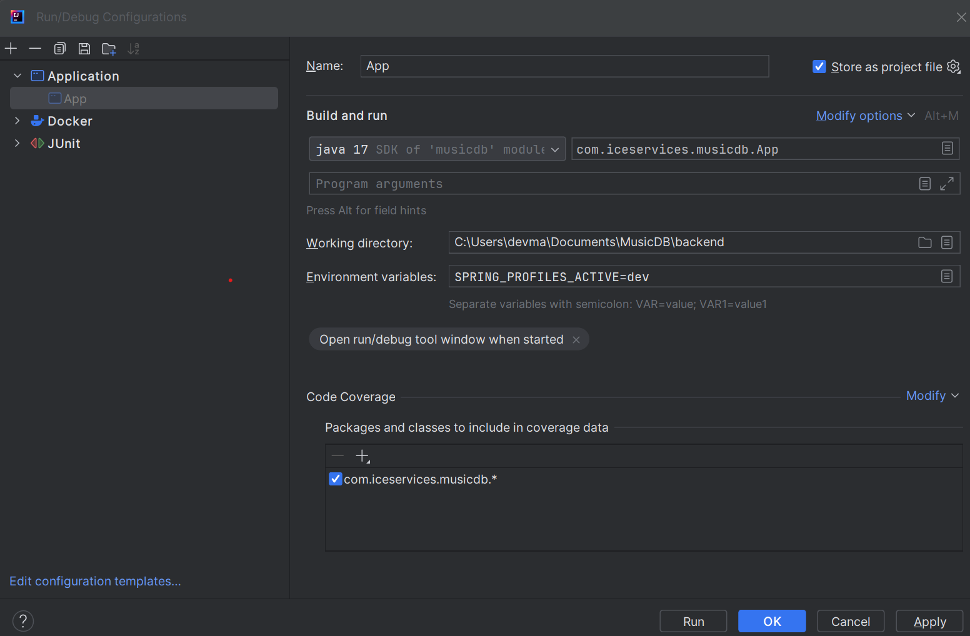
- Don’t forget to add SPRING_PROFILES_ACTIVE=dev
- You can edit backend/src/main/resources/application-dev.properties to change setting to connect to a local database instead of using H2.

If you just want to run the project and don’t want to open it, you can also use CLI.
- Open the terminal and go to inside backend folder.
- Run : ./mvnw spring-boot:run -Dspring-boot.run.profiles=dev

Note : if you are using powershell on windows (default in intellij termianl) then give space after -D
./mvnw spring-boot:run -D spring-boot.run.profiles=dev

Testing:
A postman collection is included in same location as this file to test the APIs.

Frontend
- [Optional] You don’t have to open the frontend in IDE but if you want to check the code you can use your preferred IDE.
- Open terminal and go to frontend folder.
- Run : ng serve --open

Testing:
After above command is successful you can open http://localhost:4200/ to test the application.

Docker
Dockerfiles are included in both backend and frontend and these can be used to create docker images.

